CONCEPT MODELS - PHASE 1
No | DESCRIPTION | MODEL | ADVANTAGES | DISADVANTAGES
1 | - “Modern”  - Architectural design  - Made from unusual materials (e.g. bamboo, copper/aluminium roof | 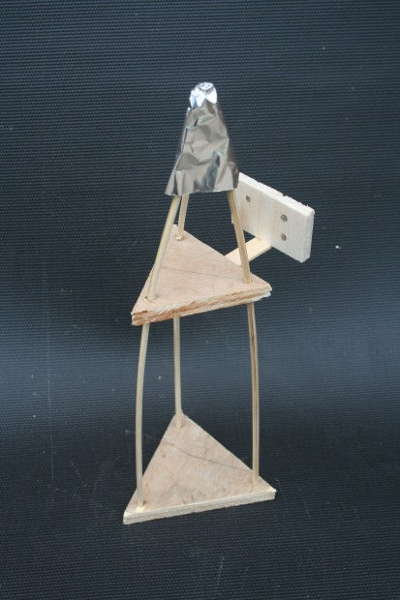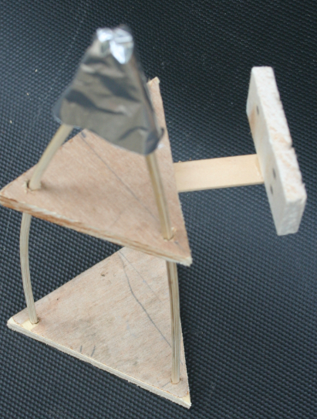 | - Attractive, unique design | - Potentially expensive  - Potentially complex construction  - Likely to be constructed as a single unit that cannot be unassembled and therefore less portable
2 | - “Rustic”  - Made from natural materials (e.g. slices of tree trunk / branch for post) | 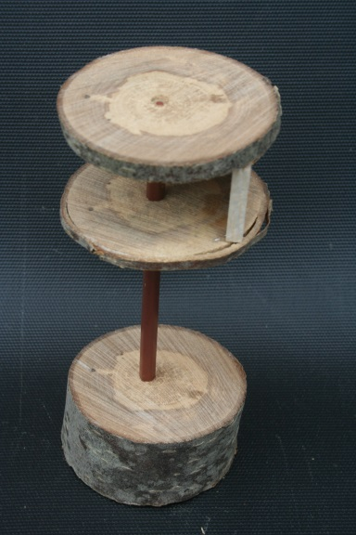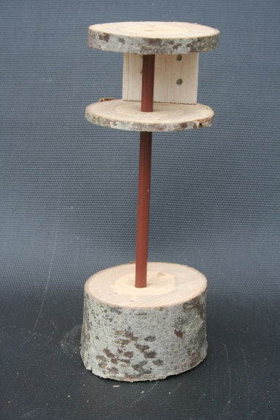 | - Blends in with surroundings  - More attractive to widlife | - Potentially difficult to find materials  - Potentially complex construction  - Likely to be constructed as a single unit that cannot be unassembled and therefore less portable
3 | - “Multi Component”  - Configurable  - Largely Plywood construction | 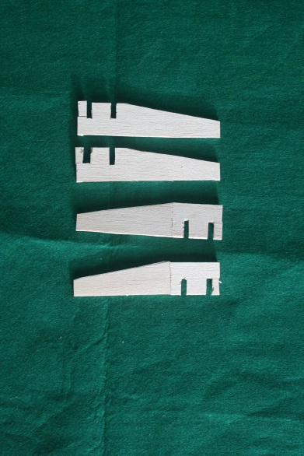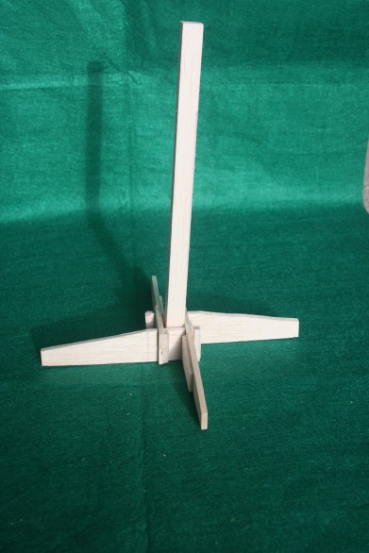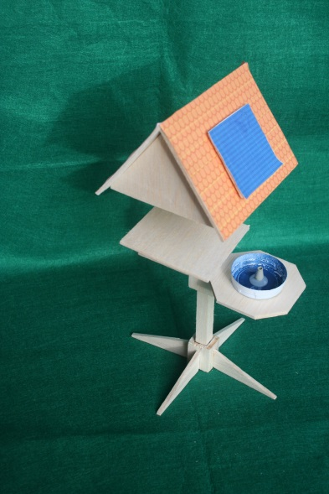 | - Easily sourced, low cost components  - Easiest to mass produce  - Dismantles / Portable  - Sell as different components  - Different configurations of components possible  - SELECTED | - Potentially least attractive

CONCEPT MODELS – PHASE 2
No | DESCRIPTION | MODEL | ADVANTAGES | DISADVANTAGES
1 | - Flat Roof  - Electronics in roof | 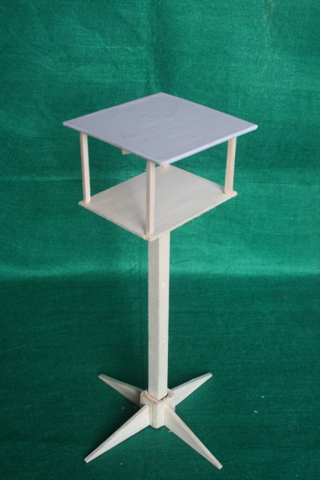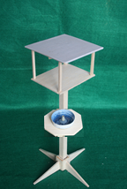 | - Simplest roof construction  - Balanced (without birdbath) | - Difficult to mount roof on posts  - Unbalanced (with birdbath)  - Food more likely to fall into birdbath  - Solar panel lies flat and will generate less energy
2 | - “Traditional” with two sided roof  - Electronics in roof | 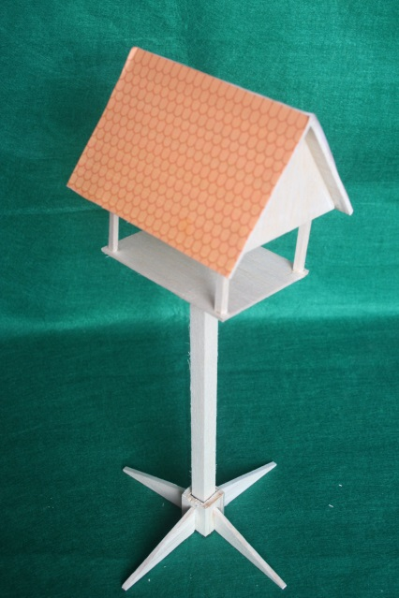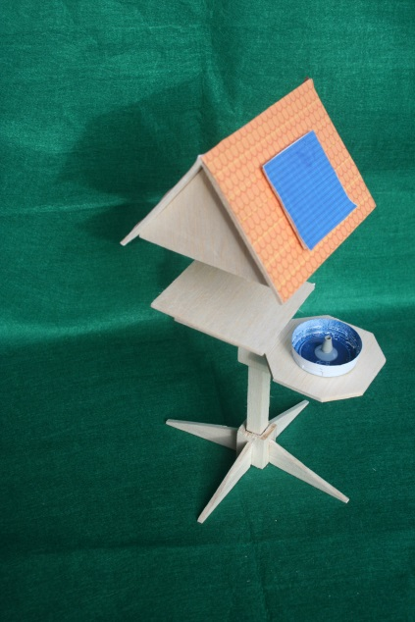 | - Balanced (without birdbath)  - Solar panel at optimal angle | - Difficult to mount roof on posts  - Unbalanced (with birdbath)  - Food more likely to fall into birdbath
3 | - “Functional”  - Single sloping roof  - Electronics in separate side box | 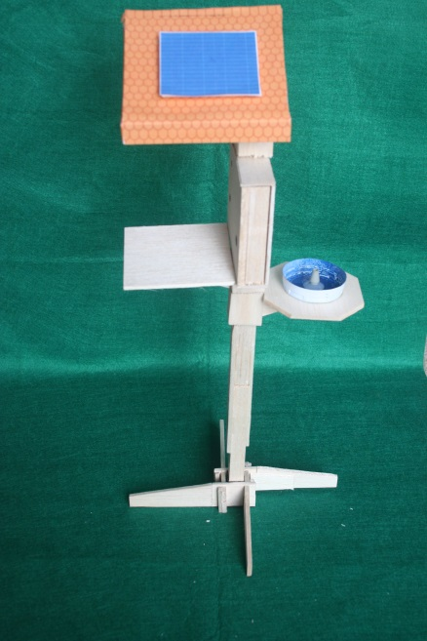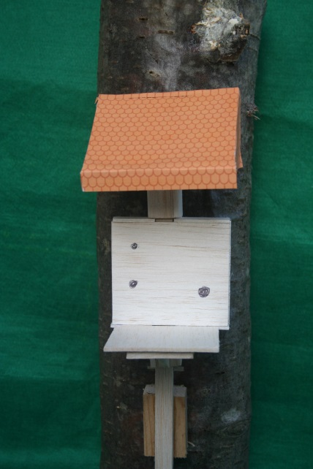 | - Can be attached to a tree or a wall (short post / no base)  - Easier roof attachment (to main post  - Easier to roof construction than “Traditional”  - Balanced (with birdbath)  - Most possible component configurations  - Food unlikely to fall into birdbath  - SELECTED | - Unbalanced (without birdbath)  - Unusual appearance

